**STAFF INFORMATION**

**DASHBOARD :**

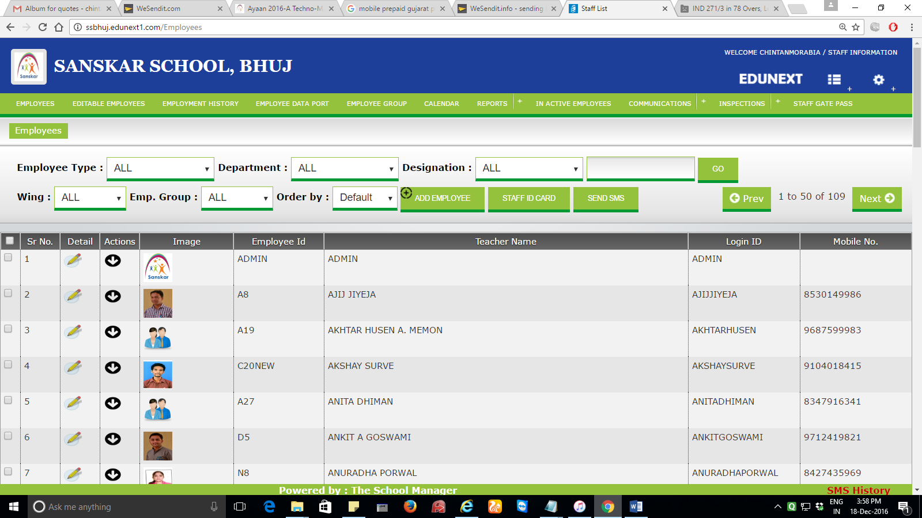

**Add employee option :**

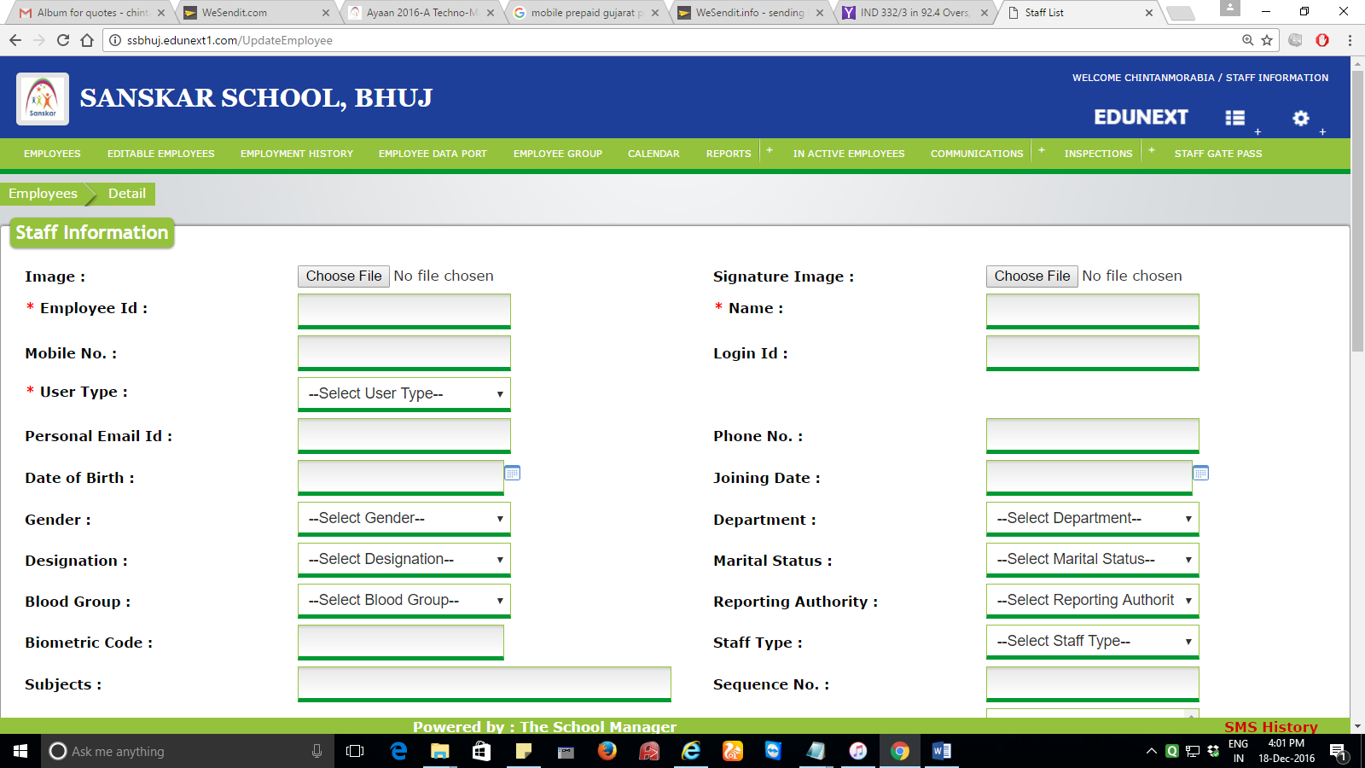

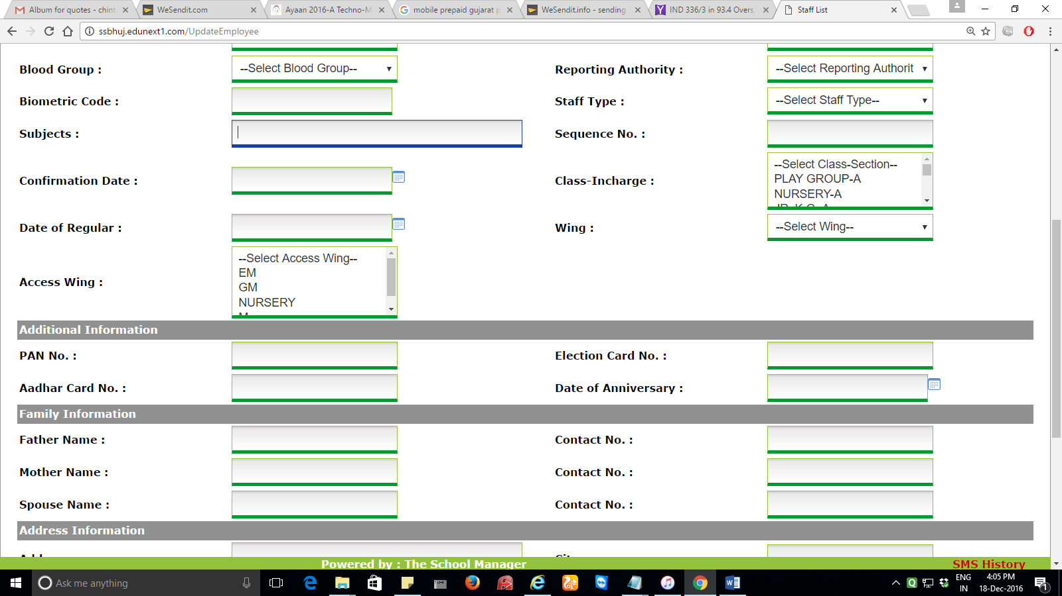

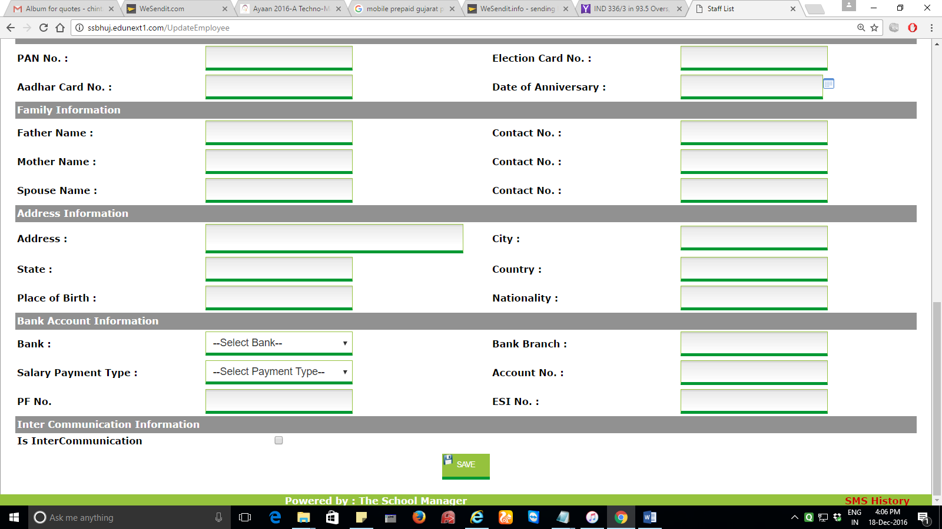

Fields which are not needed :

Staff type, confirmation date, date of regular, wing, access wing.